

How fast could your business be breached? Find out with a free Human Risk Report

If a cyber criminal set sights on your business today, how much time do you think it would take for them to dupe an unwitting employee into handing over sensitive information?

A day? A week? A month?

With user-targeted attacks becoming more frequent and sophisticated each year, it’s important for businesses to know where their human security vulnerabilities are before an attacker can exploit them. That’s why we’ve launched a new Human Risk Report service to help you shine a light on your high-risk areas - and it’s completely free.

Shine a light on your organisation's human risk areas

As part of our free Human Risk Report (HRR) service, we’ll help you understand your organisation’s human security posture against a number of key threats in just a few steps and with minimal effort, including:

- Which employees are susceptible to phishing attacks
- What user credentials are exposed on the dark web
- How quickly an attacker could breach your business through social engineering
- We’ll also calculate your organisation’s overall human risk score
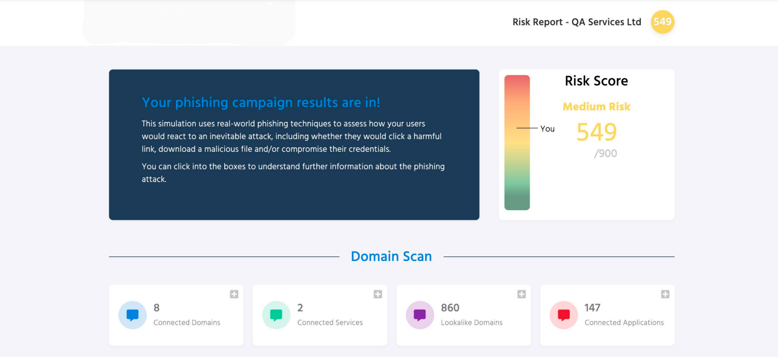

View example Human Risk Report here >>

How to claim your free Human Risk Report

Claiming your free report is easy, simply:

- Visit our Human Risk Management (HRM) page and submit the form
- We’ll then contact you to guide you through what we’ll analyse
- You’ll then get your free Human Risk Report

Included in your free report is a tailored step-by-step action plan that will guide you through the key steps your business needs to take in order to reduce its risk. You’ll also have the chance to grab a free trial of our Human Risk Management (HRM) service.

Claim your free Human Risk Report (HRR) today [insert link to your usecure landing page] >>

